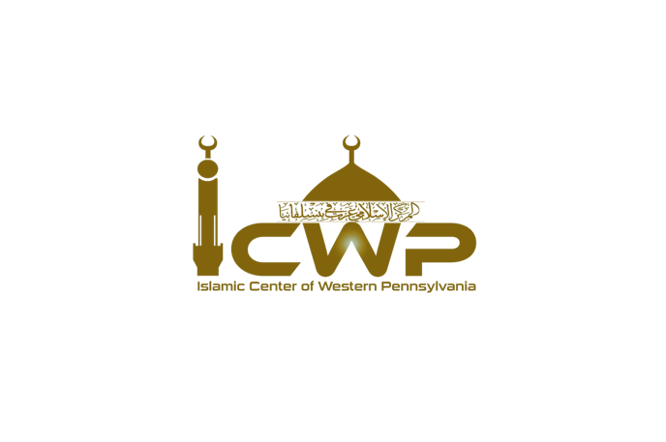
Fundraising Request Application Form
Islamic Center of Western Pennsylvania
Please complete this form to request to raise funds at our masjid. Note that your request must comply with our guidelines.

Organization Information
- Name of Organization: ___________________________
- Website: _______________________________________
- Address: _______________________________________
- Contact Person: _________________________________
- Email: _________________________________________
- Phone Number: _________________________________

Event Information
- Purpose of Fundraising: ________________________________________________________________________________________________________________________________________________________________________________________________________________________________________________________________________________________________

- Date Requested: _________________________________________________
- Has your organization raised funds at our masjid before? ☐ Yes ☐ No
  - If yes, when? _________________________________________________
- Preferred method of engagement:
  - ☐ Table at entrance/exit
  - ☐ Distribute flyers
  - ☐ Khutbah (first part religious topic, second part organization introduction)
  - ☐ Short announcement after prayer and/or Khateerah

Organization Information
- Is your organization registered as a non-profit? ☐ Yes ☐ No
  - If yes, please provide registration details: ___________________________

Additional Information
- Any additional information you wish to share: _________________________

Fundraising Request Guidelines for the Islamic Center of Western Pennsylvania
- Frequency of Visits: Organizations are allowed to come to the masjid to raise funds only once per year to avoid overwhelming the community.
- Active Fundraising Restrictions: Active fundraising (e.g., direct appeals for donations) is not permitted. However, organizations may engage with the community through other means like table set ups.
- Table Setup: A designated table can be set up near the entrance/exit for distributing flyers, brochures, and other promotional material. Volunteers can answer questions and provide information to interested individuals.
- Khutbah Guidelines: If agreed to give a khutbah, the first part should focus on a relevant religious topic. In the second part, the organization can introduce itself and its cause, and briefly explain the purpose of their visit. The Khutbah should be 20 to 25 minutes long only.

Agreement
By submitting this form, I confirm that I have read and understood the fundraising guidelines of the Islamic Center of Western Pennsylvania. I agree to comply with these guidelines and will ensure that my organization follows them during our visit.
Signature: ___________________________ Date: ___________________

Submission
Please submit this form to the following email: (icwp2019@gmail.com). For any questions, please contact Imam Yacoub (724) 910-6075 or Board President Khalid Chatta (330) 881-4072.

