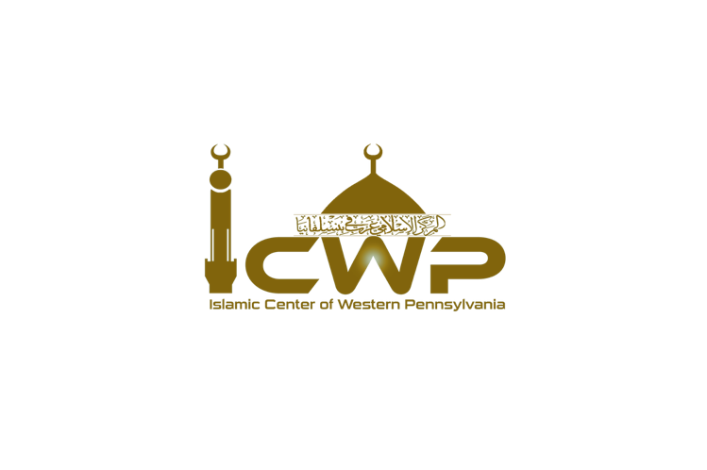
Islamic Center of Western Pennsylvania
Sadaqa Request Form

Applicant Information
- Full Name: ___________________________
- Address: ___________________________
- Phone Number: ______________________
- Email: _____________________________
- Date of Birth: ________________________
- Nationality: __________________________
Family Information
- Marital Status: ☐ Single ☐ Married ☐ Divorced ☐ Widowed
- Number of Dependents: ________________
- Ages of Dependents: __________________
Financial Situation
- Are you currently employed? ☐ Yes ☐ No
  - If yes, where do you work? __________________________________________
  - Monthly Income: __________________
- Do you receive any government or community assistance? ☐ Yes ☐ No
  - If yes, please specify: _______________________________________________
- Do you have any debts or loans? ☐ Yes ☐ No
  - If yes, please provide details: _________________________________________
- What is your current housing situation?
☐ Own a home ☐ Rent a home ☐ Living with relatives/friends ☐ Homeless
- Monthly Rent/Mortgage: _________________
Reason for Sadaqa Request
Please explain your current financial difficulties and why you are requesting Sadaqa:

Amount of Sadaqa Requested: ______________________________
Have you requested Sadaqa from ICWP before? ☐ Yes ☐ No
If yes, when and how much did you get? ______________________________
Supporting Documents
Please, if possible, attach any documents that will help verify your need for assistance, such as:
- Proof of income (pay stubs, bank statements, etc.)
- Bills (utility bills, rent/mortgage statements)
- Medical expenses
- Debt statements
Declaration
I certify that all the information provided is true and complete to the best of my knowledge. I understand that providing false information may result in the denial of my request for Sadaqa.
Signature: _________________________
Date: ____________________________

Form Submission
Please submit this form to this email: icwp2019@gmail.com.

Note:
Scholars say it is forbidden to ask for money without a genuine need, and it is even worse to lie to obtain money. Those who do so must repent to Allah. Lying, especially when requesting Sadaqa, is severely prohibited. In the hadith, the Prophet (peace and blessings be upon him) said: "A person will continue to beg from others until they meet Allah without a piece of flesh on their face" (Narrated by Muslim). It is also reported: "Whoever asks people for their wealth in order to accumulate more, is only asking for a piece of fire, so let them take little or much."

