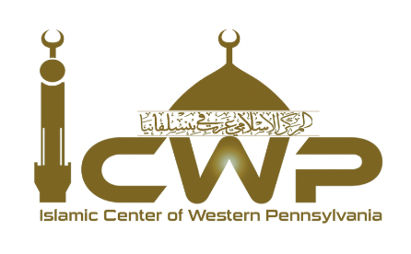
Islamic Center of Western Pennsylvania
Matrimonial Application
After you fill it out, please send it to icwp2019@gmail.com
Full Name:
Date of Birth:
Gender:

Height

Contact Number

Email Address

State/City

Nationality (Immigration status in non-US citizen)

Ethnic Background

What are you looking for in your potential spouse?

